Domain Name System

what is Domain Name System
# Source: AI Source: Provided by: [Data Path: Persons Table -> ID Column: 1, Name_En Column: Motasem Essam] -> From: [ChatGPT] on [1/18/2026]
The Domain Name System (DNS) is like the internet’s phonebook.
Instead of remembering complex IP addresses like 192.0.2.1, you just type a domain name like google.com, and DNS translates that name into the correct IP address so your browser can load the website.

In a bit more detail:
# Source: AI Source: Provided by: [Data Path: Persons Table -> ID Column: 1, Name_En Column: Motasem Essam] -> From: [ChatGPT] on [1/18/2026]
- When you enter a web address (like example.com), your computer asks a DNS server to find the IP address that matches that name.
- The DNS server looks it up in its records (or asks other DNS servers if needed) and sends back the IP address.
- Your device then uses that IP to connect to the correct server and load the website.

🔁 How DNS Works (Simplified)
# Source: AI Source: Provided by: [Data Path: Persons Table -> ID Column: 1, Name_En Column: Motasem Essam] -> From: [ChatGPT] on [1/18/2026]
- You type www.example.com in your browser.
- The browser checks local cache (did I look this up recently?).
- If not found, it asks a DNS resolver (usually your ISP or OS).
- The resolver contacts a series of DNS servers:
  - Root server → sends it to...
  - TLD server (.com, .org, etc.) → sends it to...
  - Authoritative DNS server for example.com
- The final server responds with the IP address of the site.
- Your browser connects to the website using that IP.

Why DNS is important:
# Source: AI Source: Provided by: [Data Path: Persons Table -> ID Column: 1, Name_En Column: Motasem Essam] -> From: [ChatGPT] on [1/18/2026]
- Makes the internet easier to use (humans are better at remembering names than numbers).
- Helps manage and route traffic.
- Supports features like email routing, subdomains, and content delivery.

🔍 Common DNS Terms
# Source: AI Source: Provided by: [Data Path: Persons Table -> ID Column: 1, Name_En Column: Motasem Essam] -> From: [ChatGPT] on [1/18/2026]
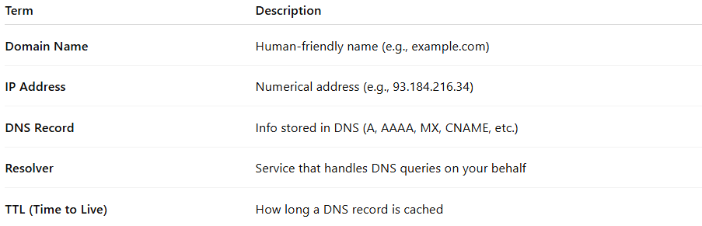

Term | Description
Domain Name | Human-friendly name (e.g., example.com)
IP Address | Numerical address (e.g., 93.184.216.34)
DNS Record | Info stored in DNS (A, AAAA, MX, CNAME, etc.)
Resolver | Service that handles DNS queries on your behalf
TTL (Time to Live) | How long a DNS record is cached

📄 Common DNS Record Types
# Source: AI Source: Provided by: [Data Path: Persons Table -> ID Column: 1, Name_En Column: Motasem Essam] -> From: [ChatGPT] on [1/18/2026]
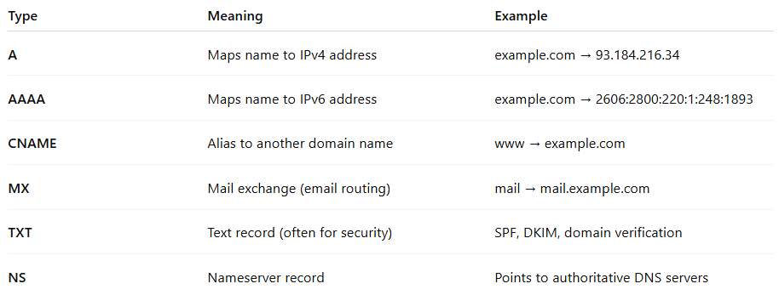

Type | Meaning | Example
A | Maps name to IPv4 address | example.com → 93.184.216.34
AAAA | Maps name to IPv6 address | example.com → 2606:2800:220:1:248:1893
CNAME | Alias to another domain name | www → example.com
MX | Mail exchange (email routing) | mail → mail.example.com
TXT | Text record (often for security) | SPF, DKIM, domain verification
NS | Nameserver record | Points to authoritative DNS servers

🔐 Is DNS Secure?
# Source: AI Source: Provided by: [Data Path: Persons Table -> ID Column: 1, Name_En Column: Motasem Essam] -> From: [ChatGPT] on [1/18/2026]
- Traditional DNS is unencrypted (can be intercepted).
- Modern improvements:
  - DNS over HTTPS (DoH) 🔒
  - DNS over TLS (DoT) 🔐
  - DNSSEC ✅ Validates responses using cryptographic signatures

✅ Summary
# Source: AI Source: Provided by: [Data Path: Persons Table -> ID Column: 1, Name_En Column: Motasem Essam] -> From: [ChatGPT] on [1/18/2026]
DNS = Domain Name System
🔁 Converts names ↔ IPs
🌍 Essential for accessing websites
🔐 Modern DNS uses encryption for security

